EPD AUSTRALASIA REGISTRATION FORM

PROCESS FOR REGISTRATION
- Appoint an Approved Verifier or Certification Body to undertake the verification of your EPD.
- Complete this form and forward to the EPD Australasia Programme Secretariat at info@epd-australasia.com. Once executed by you, this form will create a legally binding agreement between you and EPD Australasia Limited.
- Complete draft EPD, including Verification Report.
- Request EPD registration number(s) from the EPD Australasia Programme Secretariat.
- You will then receive an invoice for the annual fee (see terms and conditions below).
- Review the draft EPD against the current programme rules (the General Programme Instructions of the International EPD Systems and the current EPD Australasia regional annex to the General Programme Instructions).
- Make any necessary amendments and finalise your EPD.
- Send the following documents to the Secretariat for publication.
  - The final EPD (in MS Word or PDF document) in English.
  - A copy of the verification statement or certificate of EPD Process Certification. For a construction product EPD, according to EN 15804-compliant PCRs, the verification report for construction product EPDs must be filled in and signed by the verifier.
  - A short description and high-resolution picture of the declared product or service.
  - Your company/association logotype.
Please note that the maximum size of an e-mail is 15 MB
- You will receive an invoice for the registration and publication of your EPD on the EPD Australasia and International EPD System websites.

INFORMATION ABOUT THE REGISTERING ORGANISATION

Name of organisation:
GST (NZ) or ABN (AU) number:
Company size (number of FTE employees): (if Trade Association enter N/A) | ≤20  >20 and ≤250 | >250  N/A
Annual turnover: (if Trade Association enter N/A) | ≤$10m  >$10m and ≤$50m | >$50m and ≤$100m  >$100m  N/A
Address:
Invoice address (if different from above):
Website:
Main contact person name:
Main contact person position:
Main contact e-mail:
Main contact phone:
Contact e-mail for invoices (if different):

INFORMATION ABOUT THE EPDs AND VERIFIER

 | EPD title | Reference PCR (Name, PCR number and version) | Category of EPD  (See Table 1) | EPD keywords  (Search terms)
EPD 1
EPD 2
EPD 3
EPD 4
EPD 5
Name of LCA/EPD Consultant or Tool
Name of Approved Verifier or Process EPD Certification Body

Additional registration options:

We would also like to create a single-page Climate Declaration(s) produced based on each Australasian EPD
(Note: An additional one-off administration fee applies – see below)

DECLARATION
I herewith apply to register the above EPD(s) with EPD Australasia Limited. I confirm the accuracy of the attached documentation and am authorised to agree to the terms and conditions included below. I agree that the main contact name and contact email address provided in this Registration Form may be stored electronically, added to EPD Australasia’s mailing list, and used as contact information regarding the EPD(s) and the services under this Registration Form.

Name: |  | Date:
 |  | (Signature)

Please send to Kelly Taylor, EPD Programme Manager at info@epd-australasia.com.au

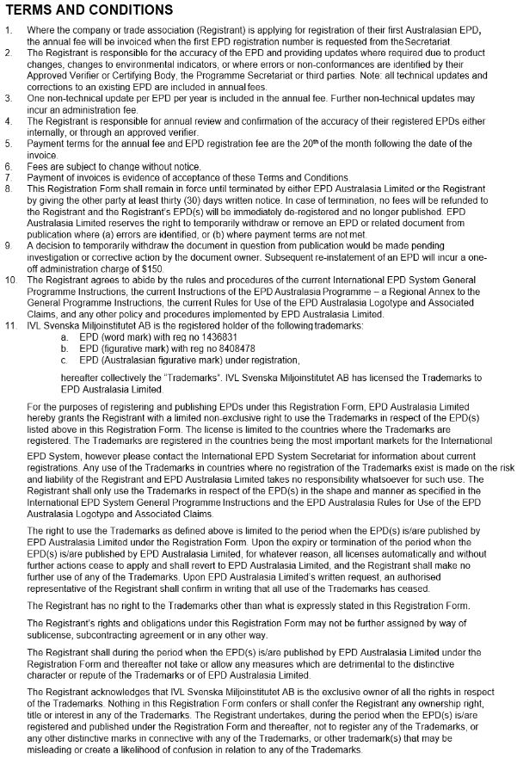

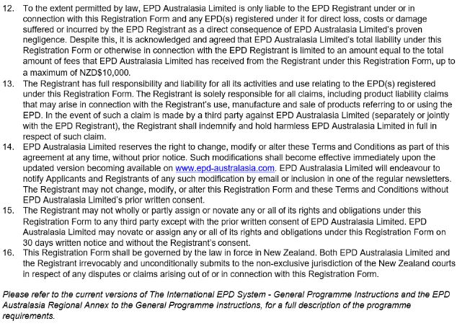

EPD categories
Please check each box (maximum of two categories).

Table 1: EPD categories
Building & construction products
Aggregates
Asphalt mixtures
Cement & building limes
Cladding & facade elements
Concrete & concrete elements
Floor systems
Gutters & downpipes
Insulated panels
Interior lining & panels
Lighting
Other building & construction products (Please name)

Paint & coatings
Pipes
Steel & other metal products
Thermal insulations
Wood & wood-based products
Food and Beverage
Furniture
Infrastructure & buildings
Rolling stock (trains & trams)
Tissue products
Wood pulp
Other non-building products (Please name)

Fees

Annual Fees
The annual fee is a recurring fee which must be paid by the EPD owner from the date of first EPD registration. The annual fee is paid per organisation per Table 2 below.

Table 2: Annual fees
Organisation criteria | Fee category | Annual fees (ex GST if applicable)
 |  | NZD | AUD
Employ <20 staff and turnover ≤$10m | Micro | 825 | 790
Employ 20-250 staff and turnover ≤$10m | SME | 1,925 | 1,830
Employ >250 staff or turnover >$10m and ≤$50m | LGE Cat A | 4,400 | 4,180
Turnover >$50m and ≤$100m | LGE Cat B | 4,600 | 4,370
Turnover >$100m | LGE Cat C | 4,950 | 4,700
Business unit of LGE Cat A with turnover ≤$10m | BU LGE Cat A | 1,925 | 1,830
Business unit of LGE Cat B or C with turnover >$10m | BU LGE Cat BC | 2,300 | 2,185
Industry or trade body or association | Trade Association | 4,400 | 4,180
Note: Employee numbers are full-time equivalents. The higher turnover will apply where organisation don’t provide a figure.

EPD Australasia Joining Fees
A one-off fee of NZD1,800 or AUD1,710 applies for all organisations joining the Programme.

Pricing Reviews
Fees are subject to change without notice. Australian pricing is reviewed regularly to maintain alignment with base New Zealand prices. Exchange rate fluctuations with variation of +/- 10% or greater will trigger pricing adjustments with a 1-month notice period.

Climate Declarations Administration Fee
One-off additional Administration fee of NZD150 or AUD130 per Climate Declaration.

Pre-certified Australasian EPD
For registration and publication fees of a pre-certified EPD please contact the Secretariat.

